EXPERIMENT NO. 1
BASIC CALCULATOR
Prolog Code
student :-
write('Name: Swethambigai S'), nl,
write('Reg No: 192565064'), nl.

add(A, B, R) :-
R is A + B.

subtract(A, B, R) :-
R is A - B.

multiply(A, B, R) :-
R is A * B.

divide(A, B, R) :-
B =\= 0,
R is A / B.
Query
student, add(10, 5, R).
Output
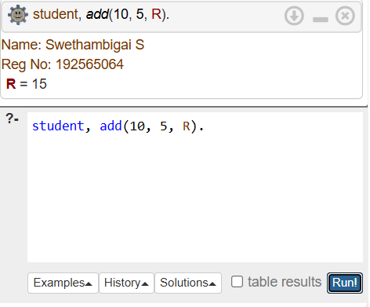

EXPERIMENT NO. 2
ALL COMPARISON
Prolog Code
student :-
write('Name: Swethambigai S'), nl,
write('Reg No: 192565064'), nl.

compare(A,B) :-
A > B, write('A is greater than B').
Query
student, compare(10,5).
Output
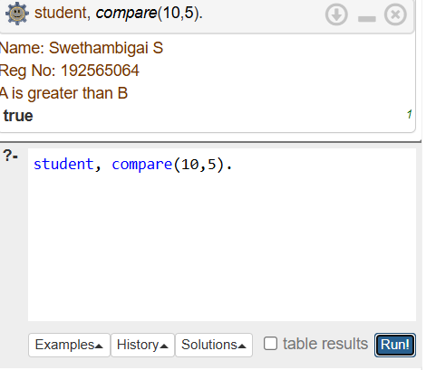

EXPERIMENT NO. 3
VOTE ELIGIBILITY
Prolog Code
student :-
write('Name: Swethambigai S'), nl,
write('Reg No: 192565064'), nl.

vote(Age) :-
Age >= 18,
write('Eligible to vote').
Query
student, vote(20).
Output
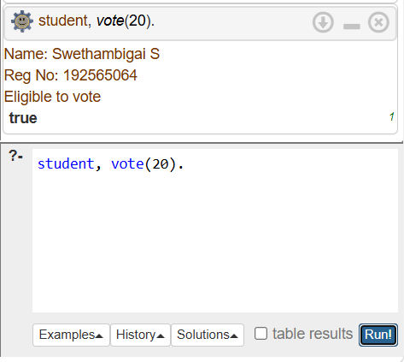
EXPERIMENT NO. 4
CELSIUS TO FAHRENHEIT
Prolog Code
student :-
write('Name: Swethambigai S'), nl,
write('Reg No: 192565064'), nl.

celsius_to_fahrenheit(C, F) :-
F is (C * 9 / 5) + 32.
Query
student, celsius_to_fahrenheit(25, F).
Output
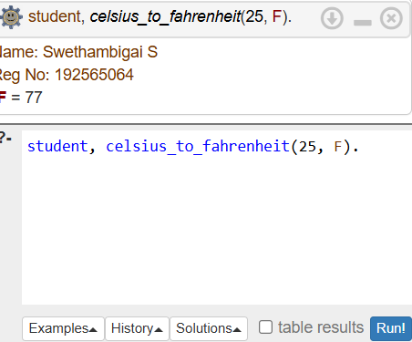

EXPERIMENT NO. 5
PASS / FAIL – 3 SUBJECTS
Prolog Code
student :-
write('Name: Swethambigai S'), nl,
write('Reg No: 192565064'), nl.

result(A,B,C) :-
A >= 40, B >= 40, C >= 40,
write('Pass').
Query
student, result(70,65,80).
Output

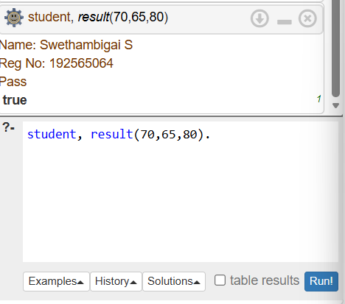

EXPERIMENT NO. 6
AVERAGE OF 5 NUMBERS
Prolog Code
student :-
write('Name: Swethambigai S'), nl,
write('Reg No: 192565064'), nl.

average(A,B,C,D,E,R) :-
R is (A+B+C+D+E)/5.
Query
student, average(10,20,30,40,50,R).
Output
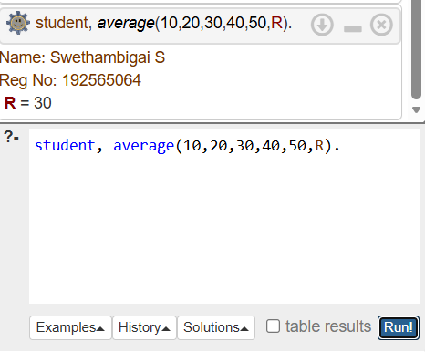

EXPERIMENT NO. 7
MULTIPLICATION TABLE
Prolog Code
student :-
write('Name: Swethambigai S'), nl,
write('Reg No: 192565064'), nl.

table(N,I) :-
I =< 10,
R is N*I,
write(N), write(' x '), write(I), write(' = '), write(R), nl,
I1 is I+1,
table(N,I1).
table(_,11).
Query
student, table(5,1).
Output

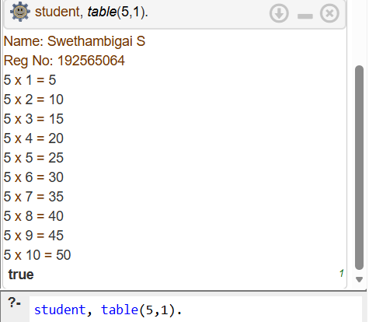

EXPERIMENT NO. 8
STUDENT TEACHER SUBJECT RELATION
Prolog Code
student :-
write('Name: Swethambigai S'), nl,
write('Reg No: 192565064'), nl.

teaches(teacher1,prolog).
studies(student1,prolog).

relation(S,T) :-
studies(S,prolog),
teaches(T,prolog).
Query
student, relation(student1,teacher1).
Output

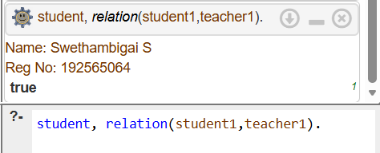

EXPERIMENT NO. 9
FAMILY TREE – ALL RELATIONS
Prolog Code
student :-
write('Name: Swethambigai S'), nl,
write('Reg No: 192565064'), nl.

male(john).
female(mary).
parent(john,mary).

father(X,Y) :-
male(X), parent(X,Y).

mother(X,Y) :-
female(X), parent(X,Y).
Query
student, father(john,mary).
Output
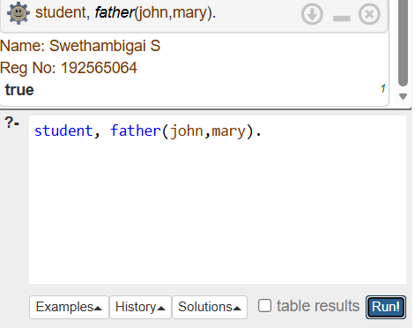

EXPERIMENT NO. 10
DIETING SYSTEM BASED ON DISEASE
Prolog Code
student :-
write('Name: Swethambigai S'), nl,
write('Reg No: 192565064'), nl.

diet(diabetes,low_sugar).
diet(bp,low_salt).

recommend(D,Diet) :-
diet(D,Diet).
Query
student, recommend(diabetes,Diet).
Output
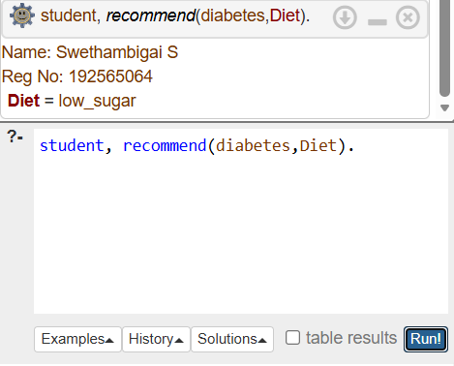

EXPERIMENT NO. 11
FORWARD / BACKWARD CHAINING
Prolog Code
student :-
write('Name: Swethambigai S'), nl,
write('Reg No: 192565064'), nl.

bird(tweety).
can_fly(tweety).

forward :-
bird(tweety),
write('Tweety is a bird').

backward :-
can_fly(tweety),
write('Tweety can fly').
Query
student, forward.
Output
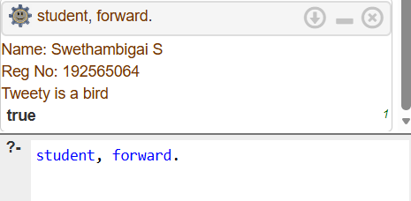

EXPERIMENT NO. 12
MONKEY BANANA PROBLEM
Prolog Code
student :-
write('Name: Swethambigai S'), nl,
write('Reg No: 192565064'), nl.

monkey_at(door).
box_at(window).
banana_at(ceiling).

get_banana :-
monkey_at(door),
box_at(window),
banana_at(ceiling),
write('Monkey can get banana').
Query
student, get_banana.
Output

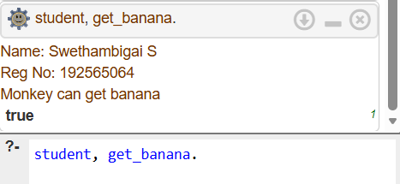

EXPERIMENT NO. 13
FRUIT AND COLOR – BACKTRACKING
Prolog Code
student :-
write('Name: Swethambigai S'), nl,
write('Reg No: 192565064'), nl.

fruit(apple,red).
fruit(banana,yellow).
fruit(grape,green).
Query
student, fruit(F,red).
Output
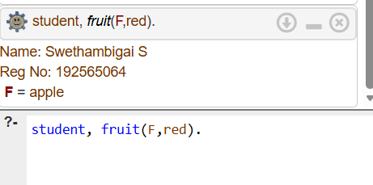

EXPERIMENT NO. 14
BIRD FLY OR NOT
Prolog Code
student :-
write('Name: Swethambigai S'), nl,
write('Reg No: 192565064'), nl.

bird(sparrow).
bird(penguin).
can_fly(sparrow).

flies(X) :-
bird(X), can_fly(X).
Query
student, flies(sparrow).
Output
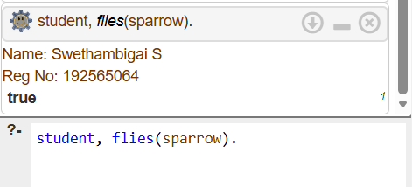

EXPERIMENT NO. 15
GRADE FIND
Prolog Code
student :-
write('Name: Swethambigai S'), nl,
write('Reg No: 192565064'), nl.

grade(M,A) :- M >= 90, A = 'A'.
grade(M,B) :- M >= 80, M < 90, B = 'B'.
grade(M,C) :- M >= 70, M < 80, C = 'C'.
grade(M,D) :- M >= 60, M < 70, D = 'D'.
grade(M,F) :- M < 60, F = 'F'.
Query
student, grade(85,G).
Output
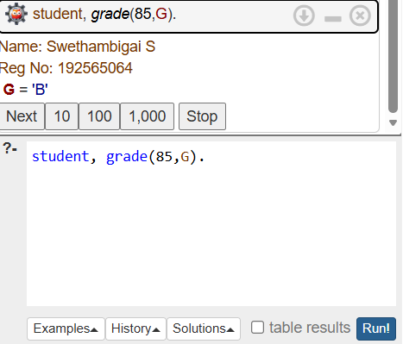

EXPERIMENT NO. 16
EB BILL PROGRAM
Prolog Code
student :-
write('Name: Swethambigai S'), nl,
write('Reg No: 192565064'), nl.

eb_bill(Units,Bill) :-
Bill is Units * 2.
Query
student, eb_bill(100,Bill).
Output

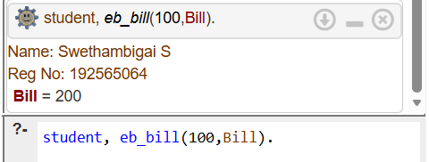

EXPERIMENT NO. 17
STUDENT DATABASE
Prolog Code
student :-
write('Name: Swethambigai S'), nl,
write('Reg No: 192565064'), nl.

student_data(101,alice,20).
student_data(102,bob,21).
student_data(103,charlie,19).
Query
student, student_data(102,N,A).
Output

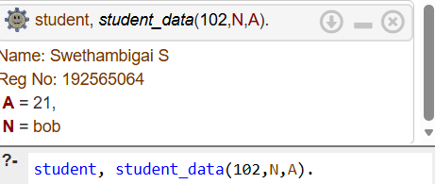

EXPERIMENT NO. 18
PRINT 1 TO 10
Prolog Code
student :-
write('Name: Swethambigai S'), nl,
write('Reg No: 192565064'), nl.

print_numbers(11).
print_numbers(N) :-
write(N), nl,
N1 is N+1,
print_numbers(N1).
Query
student, print_numbers(1).
Output

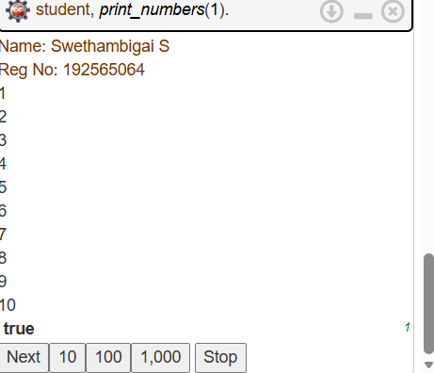

EXPERIMENT NO. 19
N QUEENS PROBLEM
Prolog Code
student :-
write('Name: Swethambigai S'), nl,
write('Reg No: 192565064'), nl.

queens(Q) :-
Q = [2,4,1,3],
write(Q).
Query
student, queens(Q).
Output
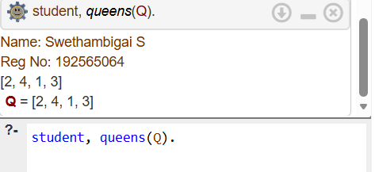

EXPERIMENT NO. 20
REVERSE A NUMBER
Prolog Code
student :-
write('Name: Swethambigai S'), nl,
write('Reg No: 192565064'), nl.

reverse_number(N,R) :-
reverse_number(N,0,R).

reverse_number(0,R,R).
reverse_number(N,A,R) :-
N > 0,
D is N mod 10,
N1 is N // 10,
A1 is A*10+D,
reverse_number(N1,A1,R).
Query
student, reverse_number(1234,R).
Output

